

Highcliffe School Student Bulletin

Monday 14th July – Friday 18th July 2008: Week A

Thought For The Week:
A loving heart is the truest wisdom. Charles Dickens

News Topic of the Week:
Young pupils choose healthy meals
‘See http://news.bbc.co.uk/cbbcnews/hi/uk/default.stm

IT’S ACTIVITIES WEEK!

- Make sure you know what you are doing on each day!
- Unless a trip you are going on is leaving early, register every morning in your tutor rooms at 8.35am.
- Full briefing for each day with be read out in morning registration time – don’t be late and miss it!
- Unless you have been told to wear different clothes for your activity, come to school in full school uniform.
- If there are any problems with the activity lists – see Mr Yapp!

Lockers: ALL lockers should be emptied this week. ALL tops of lockers need to be cleared. Do not leave it until Friday!

School Day from September 2008: from September, lunchtime will be from 1.20pm to 2.00pm. P5 will be 2.00pm -3.05pm and school will end at 3.05pm.

Hengistbury Head Ecology trip Thursday 17th July: This information applies only to Year 8 students who are not going on the Longleat trip and are in school on this date:
Your tutor will allocate you a group number this week. Groups 1 and 2 should be outside school ready to board the coach at 8.45. Groups 3 and 4 should go to Mr. Booker's lab, SC4, at 9.00am.
Please dress appropriately for the weather that is expected and have a packed lunch with plenty of water. Absolutely no flip-flops please.
Any student who has not returned the consent form should attend school in full uniform and your tutor will tell you where to go at 9.ooam.
Any problems or questions please come and see Mr. Wilson in SC10.


Hengistbury Head Outdoor Centre, Monday – Thursday: Those students on the Hengistbury Head Trip, who are getting a mini bus, need to register quickly in the morning and then meet outside main reception. You must be there before 8.45am. Miss Martindale.

 | Monday 14th |  | Tuesday 15th |  |  | Wednesday 16th |  |  |  | Thursday 17th | Friday 18th
Year 7 | Take Your Child To Work Day |  | School Production Launch Day | Emergency Services Day |  | Climbing Wall (MYP) | International Activities |  | Beach Clean | 2X½ day English | Splashdown trip
 |  |  |  |  |  |  |  |  |  | 2X½ day Humanities | Splashdown trip
Year 7 | Students in School |  |  |  |  |  |  |  |  | Peace Posters | Students in School
 |  |  |  |  |  |  |  |  |  | HH Outdoor | Students in School
Year 8 | International Day |  | School Production Launch Day | Fishing Trip | Natural History trip | Climbing Wall (MYP) | Real Game |  | Beach Clean | Longleat trip | Year Group Bowling Trip
Year 8 | HH Outdoor |  | School Production Launch Day | Fishing Trip | Technology activities | Climbing Wall (MYP) | HH Outdoor |  | Beach Clean | Science @HH | Students in School
 |  |  |  |  | STEMNET Surfing
Year 9 | Health Day |  | School Production Launch Day | Fishing Trip | Alternative Sports | Climbing Wall (MYP) | Golf Day | Arts Day |  | Job Shadowing | Moors Valley /  Paintballing
 |  |  |  |  | Textiles trip |  |  |  |  |  | Students in School
 |  |  |  |  | HH Outdoor | Climbing Wall (MYP) | Golf Day | Yeovilton trip |  | Students in school | Students in School
Year 10 | WE  Debrief | Bowling trip / In school | School Production Launch Day | Health Day |  | Climbing Wall (MYP) | Golf Day | World Games |  | Production Day | Year Group activities
Year 10 | Devon Adventure trip
Year 12 | London trip |  | Alternative Sports |  |  | France trip |  |  |  | Paintballing | Sponsored car wash/ BBQ
Year 12 |  |  | Tuscany trip
Activities Week 2008

BIKE SECURITY EVENT

TWO RIVERS MEET SKATE PARK,
TWO RIVERS MEET LEISURE CENTRE, XCHURCH
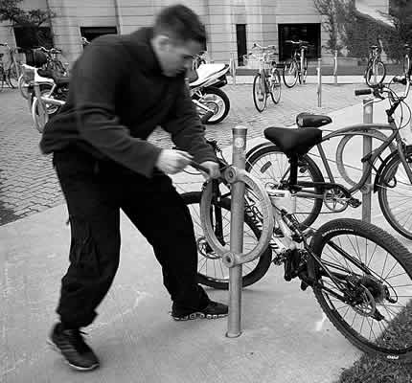


Your local Safer Neighbourhood Team will be at Two Rivers Meet Skate park on Wednesday 6th August 2008, 12pm-8pm providing advice on all aspects of bicycle security and bicycle safety.
This will include the fitting of the Immobitag – a microchip designed to help against bike theft.
(These cannot be fitted to split frame bikes. There will also be a small charge of £5 per tag (RRP £15.00))



For more info. Contact PCSO Martin Sparks 5357
Christchurch Police Station, 01202 222222

